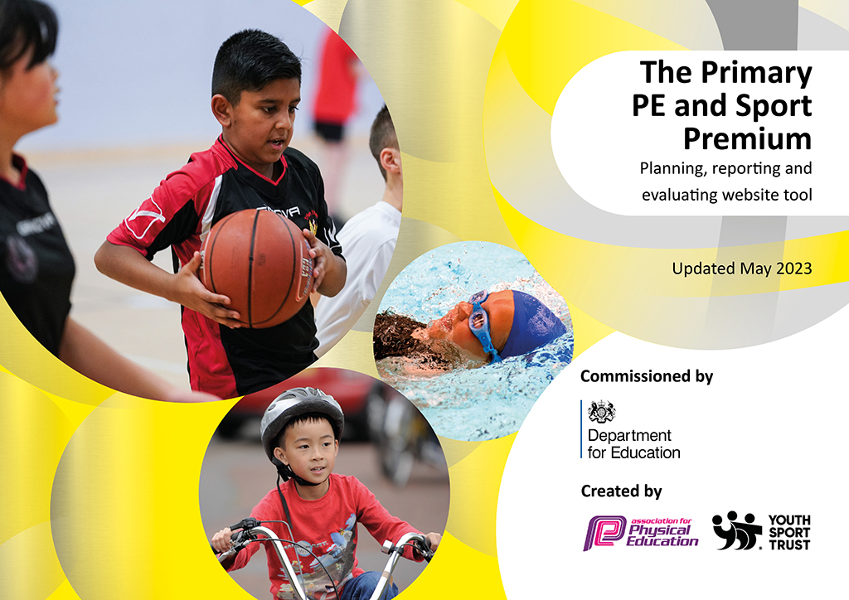
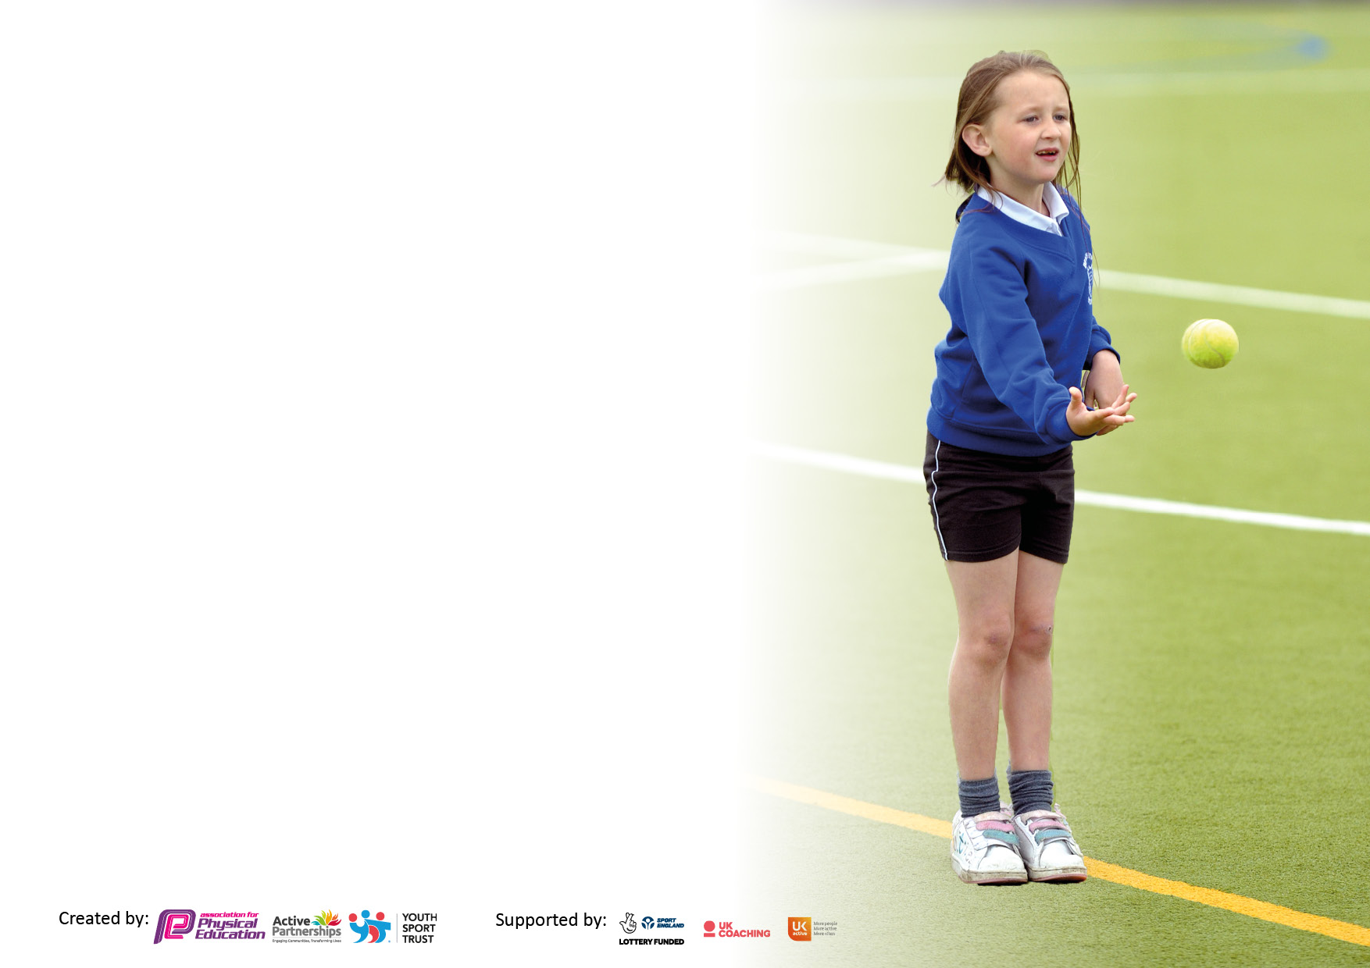

It is important that your grant is used effectively and based on school need. The Education Inspection Framework makes clear there will be a focus on ‘whether leaders and those responsible for governors all understand their respective roles and perform these in a way that enhances the effectiveness of the school’.

Under the Quality of Education judgement, Ofsted inspectors consider:
Intent - Curriculum design, coverage and appropriateness
Implementation - Curriculum delivery, teaching (pedagogy) and assessment
Impact - Attainment and progress

To assist schools with common transferable language, this template has been developed to utilise the same three headings which should make your plans easily transferable between working documents.

Schools must use the funding to make additional and sustainable improvements to the quality of Physical Education, School Sport and Physical Activity (PESSPA) they offer. This means that you should use the Primary PE and sport premium to:

- Develop or add to the PESSPA activities that your school already offers
- Build capacity and capability within the school to ensure that improvements made now will benefit pupils joining the school in future years
- The Primary PE and sport premium should not be used to fund capital spend projects; the school’s budget should fund these.

Please visit https://www.gov.uk/guidance/pe-and-sport-premium-for-primary-schools for the revised DfE guidance, including the 5 key indicators across which schools should demonstrate an improvement. This document will help you to review your provision and to report your spend. DfE encourages schools to use this template as an effective way of meeting the reporting requirements of the Primary PE and Sport Premium.

We recommend you start by reflecting on the impact of current provision and reviewing the previous spend.

Schools are required to publish details of how they spend this funding, including any underspend from 2021/2022, as well as on the impact it has on pupils’ PE and sport participation and attainment.

We recommend regularly updating the table and publishing it on your website throughout the year. This evidences your ongoing self-evaluation of how you are using the funding to secure maximum, sustainable impact. Final copy must be posted on your website by the end of the academic year and no later than the 31 July 2023.

Details with regard to funding
Please complete the table below.

Total amount carried over from 2021/22 | £ 416
Total amount allocated for 2022/23 | £ 17940
How much (if any) do you intend to carry over from this total fund into 2023/24? | £ 0
Total amount allocated for 2022/23 | £ 18356
Total amount of funding for 2022/23 to be reported on by 31st July 2023 | £ 18356
Swimming Data
Please report on your Swimming Data below.

Meeting national curriculum requirements for swimming and water safety.

N.B. Complete this section as best you can. For example, you might have practised safe self-rescue techniques on dry land which you can then transfer to the pool when school swimming restarts.
Due to exceptional circumstances priority should be given to ensuring that pupils can perform safe self-rescue even if they do not fully meet the first two requirements of the NC programme of study
What percentage of your current Year 6 cohort swim competently, confidently and proficiently over a distance of at least 25 metres?  N.B. Even though your pupils may swim in another year, please report on their attainment on leaving primary school at the end of the summer term 2023.  Please see note above | 83%
What percentage of your current Year 6 cohort use a range of strokes effectively [for example, front crawl, backstroke and breaststroke]?  Please see note above | 83%
What percentage of your current Year 6 cohort perform safe self-rescue in different water-based situations? | 94%
Schools can choose to use the Primary PE and sport premium to provide additional provision for swimming, but this must be for activity over and above the national curriculum requirements. Have you used it in this way? | No

Action Plan and Budget Tracking
Capture your intended annual spend against the 5 key indicators. Clarify the success criteria and evidence of impact that you intend to measure to evaluate for pupils today and for the future.

Academic Year: 2022/23 | Total fund allocated: | Date Updated:
Key indicator 1: Increase confidence, knowledge and skills of all staff in teaching PE and sport |  |  |  | Percentage of total allocation:
 |  |  |  | %
Intent | Implementation |  | Impact
Your school focus should be clear on what you want the pupils to know and be able to do. What do they need to learn and to consolidate through practice: | Make sure your actions to achieve are linked to your intentions: | Funding allocated: | Evidence of impact:  What do pupils now know and what can they now do? What has changed? | Sustainability and suggested next steps:
To ensure High Quality PE lessons across school and the resources required to plan, deliver and assess a wide, broad and balanced PE and School curriculum. | Purchase of the Complete PE scheme of work, including the online and paper resources.  Link the assessment of PE to the curriculum mapping (September 2021) and Evidence me digital resource.  CPD of scheme use for all staff. | £ ****  £ **** | Staff report an increased confidence in the delivery of PE and knowledge of progression and assessment.  Observations of PE lessons shows well structured, progressive and differentiated lessons teaching core skills.  Evidence Me allows staff to now accurately level and show the progress of pupils against set criteria – This is reported in the annual reports for pupils. | Increased participation in lessons and resulting provision of extracurricular activities will be developed into a
Key indicator 2: The engagement of all pupils in regular physical activity – Chief Medical Officers’ guidelines recommend that  primary school pupils undertake at least 30 minutes of physical activity a day in school |  |  |  | Percentage of total allocation:
 |  |  |  | %
Intent | Implementation |  | Impact
Your school focus should be clear on what you want the pupils to know and be able to do. What do they need to learn and to consolidate through practice: | Make sure your actions to achieve are linked to your intentions: | Funding allocated: | Evidence of impact:  What do pupils now know and what can they now do? What has changed? | Sustainability and suggested next steps:
Ensure children have access to age-appropriate active travel training to encourage children to walk or cycle to school safely. | Year 3 pupils take part in Pedestrian training to learn how to cross the road safely.  Y6 pupils take part in Bikeability Level 1 & 2 training to learn how to ride their bikes safely on the road  Assembly on Active Travel. | Bikeability Training Cost: Part of CSSP Buy in. (Part of £3,000). | In Sept 2021 >80% of children travelled to school by walking or cycling or scooting (show of hands during assembly)  Less congestion at the school gate for drop off and pick up times.  Children are more confident and competent to ride on roads and cross the roads safely. | Each year the next cohort will be trained.  School staff fully understand the outcomes and consolidate this learning back in school.  Parents understand the school is an ‘active school’ and the benefits of walking their child to school and spending quality time on a morning.

Key indicator 3: The profile of PE and sport is raised across the school as a tool for whole school improvement |  |  |  | Percentage of total allocation:
 |  |  |  | %
Intent | Implementation |  | Impact
Your school focus should be clear on what you want the pupils to know and be able to do. What do they need to learn and to consolidate through practice: | Make sure your actions to achieve are linked to your intentions: | Funding allocated: | Evidence of impact:  What do pupils now know and what can they now do? What has  changed? | Sustainability and suggested next steps:
Develop leadership skills in children | CSSP trained sports leaders  A member of staff accompanied the children to the training and now leads the sports leaders team within school.  The children deliver physical activity sessions at break and lunchtimes.  The leaders will also support intra school events, including cross country and sports day.  Activity breaks well embedded across the school to allow children to refocus on their learning | Leadership Training Cost: Part of CSSP Buy in. (Part of £3,000). | Pupils have increased self-esteem and confidence.  Young leaders benefit from the experience of planning,  organising and delivering a range of sports to a diverse group of children. They became more confident in their leadership qualities.  Staff benefit from training by CSSP so they understand their role back at school with the sports leaders.  A more active school has been achieved by having the ‘mini workforce’ at break and lunchtimes – Summer 2022  Better attainment and behaviours for learning. Best SATS results and phonics the school has achieved 2022-2023. | ALL Y6 currently trained. We need to continue this year on year and have the older leaders mentor the younger ones – each year training the Year 5 in readiness for September.  Download more activity cards for the sports leaders to give them ideas for new games.
Key indicator 4: Broader experience of a range of sports and physical activities offered to all pupils |  |  |  | Percentage of total allocation:
Intent | Implementation |  | Impact
Your school focus should be clear on what you want the pupils to know and be able to do. What do they need to learn and to consolidate through practice: | Make sure your actions to achieve are linked to your intentions: | Funding allocated: | Evidence of impact:  What do pupils now know and what can they now do? What has  changed? | Sustainability and suggested next steps:
To ensure that all children and young people enjoy some form of sport or physical activity | Take part in CSSP festivals and development days.  Introduced active play at break and lunchtimes.  Started a Gymnastics club for Key Stage 1 pupils.  Regular clubs – Outdoor and Adventurous, Football. | Cost of Judo Sessions: FREE  Festival & Development Days Cost: Part of CSSP buy in (Part of £3,000).  New equipment cost: £ | 24 pupils regularly attend the school Football Club.  15 pupils attending weekly OAA club.  The children are engaged more in PE and after school clubs due to the wider and broader selection of activities | Continue to enter children into sports events and festivals.  Ensure thought goes into which children are selected for which event – targeting those who are enthusiastic and may not have opportunity elsewhere.  Report after each event to enthuse other in school.

Key indicator 5: Increased participation in competitive sport |  |  |  | Percentage of total allocation:
 |  |  |  | %
Intent | Implementation |  | Impact
Your school focus should be clear on what you want the pupils to know and be able to do. What do they need to learn and to consolidate through practice: | Make sure your actions to achieve are linked to your intentions: | Funding allocated: | Evidence of impact:  What do pupils now know and what can they now do? What has  changed? | Sustainability and suggested next steps:
Ensure that every pupil, by the time they reach Y6, has represented their school in a sporting activity | Enter into CSSP competitions and festivals.  Ensure children are entered into appropriate levels of competition to suit their individual motivation, competence and confidence levels.  Keep a track of which competitions and festivals every child has attended.  Celebrate ALL participation achievements, not just the winners. | Competition Cost: Part of CSSP buy in (Part of £3,000). | Pupils’ skills developed through the experience and some developed an interest in a new activity.  Pupils have a sense of belonging to their school as they represented the school.  Pupils have improved their confidence, competence, motivation, knowledge and understanding in various sports and activities.  The children have had fun!  Staff have benefitted from the professional development opportunities through attending events and learning from the deliverers.  The events have been used as a carrot for good behaviour in school and we have seen a significant improvement. | Ensure that all children are appropriately prepared for the competition they are attending to further increase their physical literacy levels particularly their confidence and motivation levels.  Reinforce the Spirit of the Games values that CSSP are aiming to develop in our children: Honesty, Passion, Determination, Self-Belief, Respect and Teamwork.

Signed off by
Head Teacher:
Date:
Subject Leader:
Date:
Governor:
Date:

