Attendance  
Following on from my email about the importance of attendance, going forward we will publish the weekly class attendance figures. We don’t want poorly children in school, but are always keen to encourage excellent attendance from our pupils. (Data is from last week)

|  |  |
| --- | --- |
| Reception | Not all in. |
| Year 1 | 100% |
| Year 2 | 94.6% |
| Year 3 | 100% |
| Year 4 | 99.3% |
| Year 5 | 98.6% |
| Year 6 | 99.4% |

Dates for your diary:

13.09.22 Cross country trials for KS2

14.09.22 Eden Camp visit Year 6

19.09.22 Bank Holiday – school closed

20.09.22 New to Year one and two meeting – everyone is welcome from these year groups to listen to what your children will be learning and how you can help your child this year. 4.30pm in the school hall.

21.09.22 New to Year three, four, five and six meeting – everyone is welcome from these year groups to listen to what your children will be learning and how you can help your child this year. Year six pupils will also be given information about SATS testing and preparation. 4.30pm in the school hall.

26.09.22 PD day – school closed to pupils

27.09 22 Clubs will begin.

29.02.22 PTFA annual general meeting – all welcome

30.09.22 MacMillan coffee morning in school – all welcome.

18.10.22 Food bank collection following our Harvest festival celebrations.

20.10.22 Harvest Festival at St. Mark’s – morning, times and details to be confirmed.

Newsletter will be published every Monday rather than Friday – Thank you

READING

Please try to get back into the routine of reading every night. Children also love to be read to, so any opportunity to do this would be grateful appreciated.

We will start home readers and library books again over the coming weeks.

PE Kits.

Please ensure that your child only uses school PE kit when they have PE. No branded logos on T-shirts or trousers please. Long hair should also be tied up so that it doesn’t get caught during PE.

Our Queen’s funeral  
  
I was incredibly saddened yesterday to hear of the passing of our wonderful Queen – Queen Elizabeth 2. She represented our country through challenging times, always with a wonderful sense of humour – she will be really sadly missed.  
Classes have reflected upon her death and we will continue to do this over the coming days as her funeral arrangements are put into place.

**Monday 19th September is a Bank Holiday – school will be closed for the Queen’s funeral.**

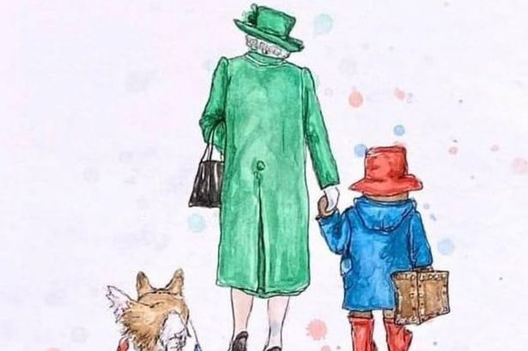

Issue: 2

Monday 12th September 2022

Head’s Lines  
*­­*