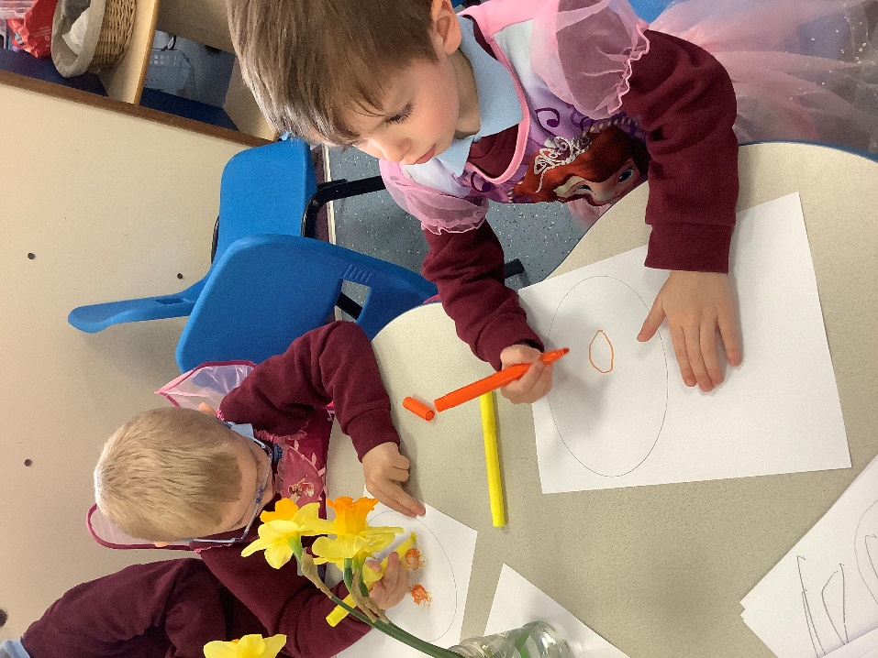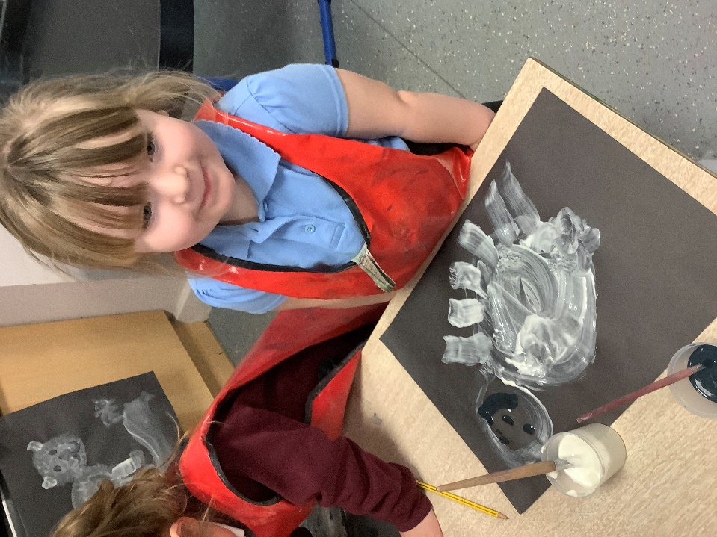

1:1 Teaching Assistant (Level 3)

Errington Primary School

Teaching Assistant, 32 hours per week, term time only, fixed term contract

Tees Valley Collaborative Trust established in November 2017, is a Multi Academy Trust based in the North East of England. www.tvc.ac.uk currently comprising of Prior Pursglove and Stockton Sixth Form College and Errington Primary School, plus a pupil referral unit in Billingham.

At Errington Primary Schoot, we are seeking a qualified Teaching Assistant with experience of working in a primary setting with pupils who have additional needs.

The successful candidate will be working with 2 children who have additional needs on a 1:1 basis. Each child has their own targets and goals as well as helping them access the full curriculum that we have on offer. The Teaching Assistant will work alongside and support the teacher in charge to enable pupils to progress working with small groups or on a one-to-one basis.

You must be Level 3 qualified and experience of working with children with SEMH needs and managing challenging behaviours is essential.

If you would like to look around school or require any additional information please contact the School Business Manager on 01642 482002.

This is a fixed term contract to 31st August 2022.

Salary: Scale 7–11 of the Local Government Support Staff Salary Spine (FTE £20,444 - £22,129 per annum)
Actual Starting Salary: £14,950.63 per annum (based on an FTE of £20,444 per annum)

Closing Date: noon on Thursday 7th April

Interview Date: Wednesday 27th April

Start Date: Immediate start available

The application pack can be downloaded from www.tvc.ac.uk or requested from the School Business Manager on 01642 482002. CVs will not be accepted.

Tees Valley Collaborative Trust is committed to safeguarding and promoting the welfare of children and young people and expects all staff and volunteers to share this commitment

As this post involves direct contact with, or unsupervised responsibility for, children or vulnerable adults the successful candidate will be required to undertake a Disclosure and Barring Service check before taking up the position. Additional checks will include; identity checks, qualification checks and employment checks, including the investigation of any gaps between jobs and two satisfactory references.

TEES VALLEY COLLABORATIVE TRUST
Church Walk
Guisborough
TS14 6BU
Tel: 01287 280800
Email: HR@tvc.ac.uk
Job Description – 1:1 Teaching Assistant

Location: Errington Primary School
Hours: 32 hours per week, term time only
Grade: LA Support Staff Pay Spine, Level 3 TA Point 7-11
Contract type: temporary – end date Summer 2022

Responsible to: Headteacher

Errington Primary school is an average sized primary school based in Marske who is proud to be part of the Tees Valley Collaborative Trust. We pride ourselves on inclusion and provide vibrant learning experiences for all of our pupils.

The Trust and Governors are seeking to appoint an enthusiastic and talented 1:1 teaching assistant who has the vision and drive to make a significant impact in school and is committed to making a difference to the lives of our children.

Job Purpose

- To assist in promoting the learning and personal development of the pupil(s) to whom you are assigned, to enable him/her to make best use of the educational opportunities available to them.
- To assist teachers in providing a learning environment that enable all children to access the curriculum and learn to the best of their ability.
- To ensure that a child’s needs are fully met to allow them to participate in all aspects of school life with the appropriate support.

To support interventions according to need in classes

To support the delivery programs of work for 1:1 support work

To deliver speech and language programs as provided by speech and language therapists

To support class teacher in delivering aspects of the curriculum

To deliver specific intervention programs

Support for the pupil

- To aid the pupil(s) to learn as effectively as possible both in group situations and on his/her own by, for example:
- Clarifying and explaining instructions
- Ensuring the pupil is able to use equipment and materials provided
- Motivating and encouraging the pupil(s) as required by providing levels of individual attention, reassurance and help with learning tasks as appropriate to pupils’ needs
- Assisting in areas of development, e.g. speech and language, reading, spelling, numeracy, handwriting/presentation etc
- Using praise, commentary and assistance to encourage the pupil to concentrate and stay on task
- Liaising with class teacher, SENCO and other professionals about individual education plans (IEPs), contributing to the planning and delivery as appropriate
- Providing additional nurture to individuals when requested by the class teacher or SENCO
- Consistently and effectively implementing agreed behaviour management strategies
- Helping to make appropriate resources to support the pupil

- To establish supportive relationships with pupils

- To promote the acceptance and inclusion of the pupils with SEN, encouraging pupils to interact with each other in an appropriate and acceptable manner

- Monitor the pupils’ responses to learning activities and, where appropriate, modify or adapt the activities as agreed with the teacher to achieve the intended learning outcomes.

- To give positive encouragement, feedback and praise to reinforce and sustain the pupil’s efforts and develop self reliance and self esteem.

- To mark pupils’ work under the direction of the class teacher

- To support pupils in developing social skills both in and out of the classroom

- To support the use of ICT in learning activities and with specific programmes to support learning.

- To provide regular feedback on the pupil’s learning and behaviour to the teacher/SENCO, including feedback on the effectiveness of the behaviour strategies adopted

- Under the direction of the teacher, carry out and report on systematic observations of pupils to gather evidence of their knowledge, understanding and skills upon which the teacher makes judgements about their stage of development

- When working with a group of pupils, understand and use group dynamics to promote group effectiveness and support group and individual performance

- Where appropriate, to know and apply positive handling techniques

- Where appropriate to develop a relationship to foster links between home and school, and to keep the school informed of relevant information

- To be aware of confidential issues linked to home/pupil/teacher/school

- To contribute towards reviews of the pupil’s progress as appropriate

- To take part in training activities offered by the school to further knowledge and skills of working with a child with specific learning difficulties

- To be willing to support playground/break time supervision e.g. educational games, homework clubs etc

Support the teacher
- To assist with general school duties which may include: setting up classrooms, preparing resources and displays and tidying and clearing away, supervising of children during playtimes
- Liaise sensitively and effectively with parents/carers as agreed with the teacher within your role/responsibility and participate in feedback sessions/meetings with parents with, or as directed.

Support the school
- Be aware of and comply with policies and procedures relating to child protection, health, safety and security, confidentiality and data protection, reporting all concerns to an appropriate person.
- Be aware of and support difference and ensure all pupils have equal access to opportunities to learn and develop
- Contribute to the overall ethos/work/aims of the school
- Establish constructive relationships and communicate with other agencies/professionals, in liaison with the teacher, to support achievement and progress of pupils
- Participate in training and other learning activities as required
- Supervise pupil on visits, trips and out of school activities as required
- Undertake planned supervision of pupils out of lesson times, including before and after school and at lunchtime.

Safeguarding, equality and diversity and health and safety
- To safeguard and promote the welfare of children for whom you have responsibility or come into contact with, to include adhering to all specified procedures.
- To carry out your duties with full regard to the Trust’s Equality Policy and objectives.
- To comply with Health and Safety policies, organisation statements and procedures, report any incidents/accidents/hazards and take a proactive approach to health and safety matters in order to protect both yourself and others.

This job description sets out the main responsibilities for the postholder, but is not intended to be an exhaustive list. Specific duties may change from time to time without changing the general nature of the post and the postholder is expected to be flexible in the range of responsibilities they undertake commensurate with the responsibility and salary

Please note that successful applicants will be required to comply with all academy trust policies. The successful applicant will be subject to full enhanced disclosure checks – and these will be subject to rechecking as appropriate.

Person Specification – Teaching Assistant

Essential

- Have studied to Advanced Level or equivalent.
- At least 5 GCSEs at A-C or equivalent level 2 qualifications, including English and Maths
- Hold a Level 3 Teaching Assistant qualification, or equivalent
- Experience of working with students with Social, Emotional and Mental Health Needs in a primary setting
- Be able to demonstrate an understanding of and empathy for learning difficulties and disabilities and have emotional resilience to work with challenging students.
- Have the ability to work on a one-to-one or group basis with young people and adults.
- Be able to demonstrate appropriate commitment to equal opportunities and inclusive learning.
- Have the ability and confidence to work with numeracy/mathematics.
- Have functional ICT skills or must be willing to develop them further.
- Have an understanding of the basic principles of safeguarding
- Working knowledge of the national/foundation curriculum and other relevant learning programmes/strategies
- Have the ability to work effectively as part of a team.
- Recognise the importance of confidentiality and ensure that it is maintained.
- Good note taking skills.
- Have good interpersonal, tact and diplomacy skills.
- Good organisational skills with a sensitive approach to work
- Have a good sense of humour and patience.
- Have high expectations of pupils and set challenging targets.
- Be flexible in their approach to work including working hours
- Be committed, enthusiasm, organized, flexible, patient and empathetic.

Desirable

- Experience of a teaching and learning environment.
- An interest in developing resources for individual students.
- Involvement with writing Individual Learning Plans.
- Training and experience of delivering Read, write, inc phonics.

